**BOOSTING CLASSIFIER(ADABOOST vs GRADIENT BOOST)**

**CODE & OUTPUT:**

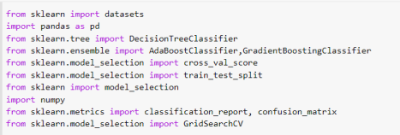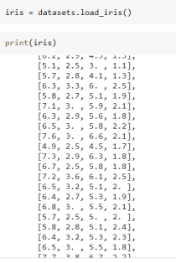

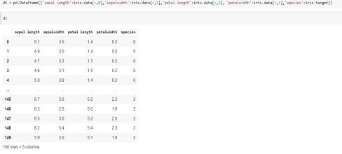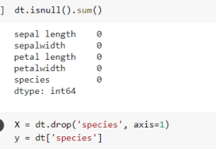



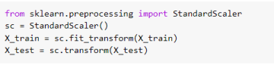

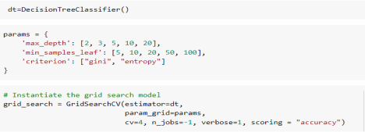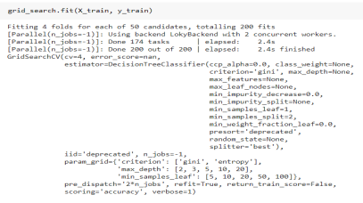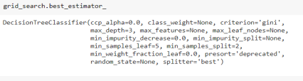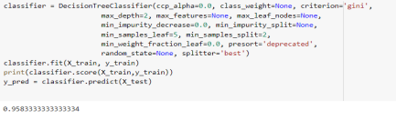

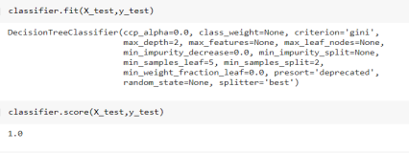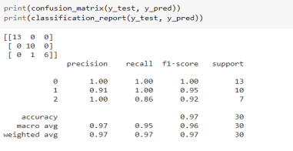

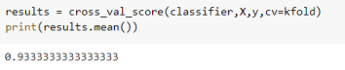

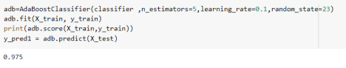









**A))**THE MODEL IS OVERFITTING.

BEFORE HYPERPARAMETER TUNING THE DECISION TREE CLASSIFIER, THE ACCURACY AND SCORE OF ALL THE 3 MODELS(DECISION TREE CLASSIFIER,ADA BOOST,GRADIENT BOOST) WERE 1.WHICH MEANS THAT THE MODEL IS OVERFITTED AND THE VARIANCE IS HIGH.

BASICALLY IT CAN BE REDUCED BY INCREASING THE TRAINING DATASET,SINCE THE TRAINING DATASET I USED IS 80% I DIDN’T INCREASE IT.THE OTHER WAY TO REDUCE IT IS THROUGH HYPERPARAMETER TUNING.

**B)**

| **TRAIN/TEST** | **MODEL ACCURACY SCORE** |
| --- | --- |
| TRAIN | DECISION TREE  0.9583333333333334  CLASSIFIER |
| TEST | DECISION TREE  1.0  CLASSIFIER |
| TRAIN | ADABOOST CLASSIFIER 0.975 |

| TEST | ADABOOST CLASSIFIER **1.0** |
| --- | --- |
| TRAIN | GRADIENT BOOST  **1.0**  CLASSIFIER |
| TEST | GRADIENT BOOST  **1.0**  CLASSIFIER |

**C)**

| **MODEL CROSS VALIDATION SCORE** |
| --- |
| DECISION TREE CLASSIFIER 0.9333333333333333 |
| ADABOOST CLASSIFIER 0.9200000000000002 |
| GRADIENT BOOST CLASSIFIER 0.9466666666666667 |